Team 4 Project Instructions

Login Screen

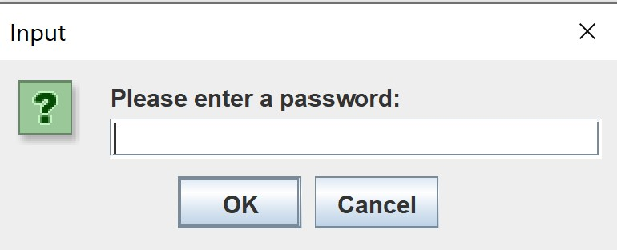

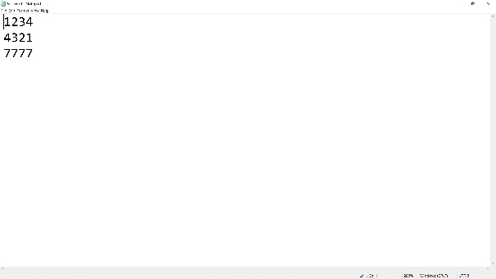

Use Instructions:

After the program is executed, the employee is transferred to the login screen where they will enter their assigned password in the form of a 4-digit pin. The pins are taken from password.txt. A correct password entry results in the launch of the menu screen.

Requirements: Security, Login Screen

Use Case: Employee Login

Menu Screen

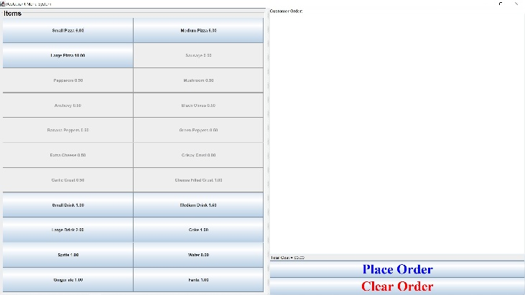

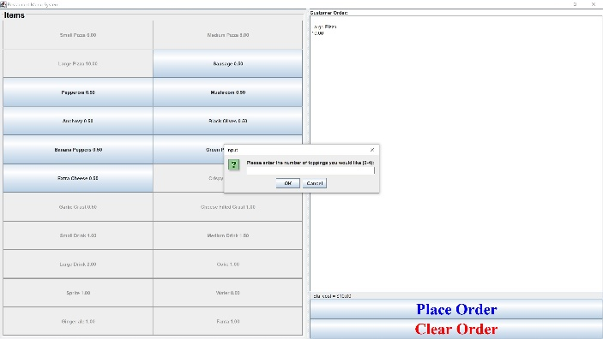

Use Instructions:

The buttons on the left side may be pressed to add to the order. Grayed-out buttons may not be pressed, as they are reserved for specific cases (EG picking a crust must happen only after a pizza is selected). After a crust is selected, a dialog box will appear asking the user how many toppings they would like on the pizza. This will allow that number of toppings to be added before reverting the menu back to its default configuration. The clear order button can be used to remove all items currently on the order. The place order button creates an output file.

Requirements: Fully functioning customizable menu that allows for touch screen usage, Running tally of cost of order

Use Case: Employee Step 3 “Prepares order”

Output File

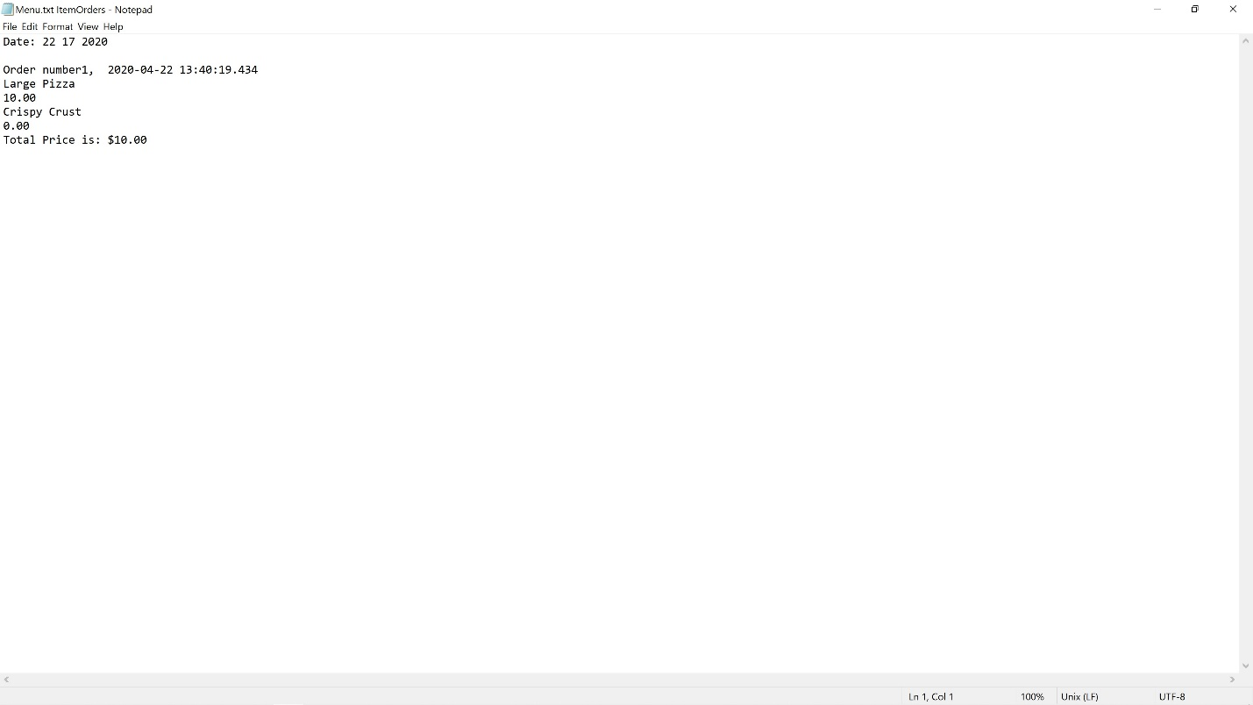

Use Instructions:

After the place order button is pressed, the output file shown above is generated. It contains each item ordered and its price, as well as the total price of the order, the order number, and the date and time at which the order was placed.

Requirements: Reporting, Receipt generation

Use Case: Employee step 3 “Prepares Order”